Criando uma API Rest simples com Laravel e Laragon
Cristian Bernardes

Vídeo: https://www.youtube.com/watch?v=daq5S5-55Lw

- No Laragon rode o Apache e o MySQL

- No Laragon, clique com o botão direito e selecione:

Criar rapidamente um website --> Laravel

- De o nome de: laravel-apirest-simples

- Clique no botão "Banco de dados"

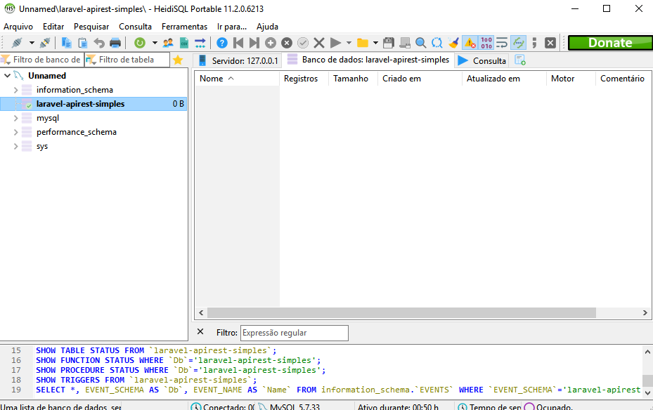

.env

APP_NAME=Laravel
APP_ENV=local
APP_KEY=base64:QL7CfGZvlBsaUX70otPyyFhu7iZ4NGQyKfel6Sii/m8=
APP_DEBUG=true
APP_URL=http://localhost

DB_CONNECTION=mysql
DB_HOST=127.0.0.1
DB_PORT=3306
DB_DATABASE=laravel-apirest-simples
DB_USERNAME=root
DB_PASSWORD=

Criando o model e a migration

php artisan make:model Dog -m

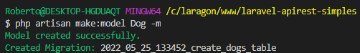

app\Models\Dog.php

<?php

namespace App\Models;

use Illuminate\Database\Eloquent\Factories\HasFactory;
use Illuminate\Database\Eloquent\Model;

class Dog extends Model
{
use HasFactory;

protected $fillable = [
'name', 'breed'
];
}

database\migrations\2022_05_25_133452_create_dogs_table.php

<?php

use Illuminate\Database\Migrations\Migration;
use Illuminate\Database\Schema\Blueprint;
use Illuminate\Support\Facades\Schema;

class CreateDogsTable extends Migration
{
public function up()
{
Schema::create('dogs', function (Blueprint $table) {
$table->id();
$table->string('name');
$table->string('breed');
$table->timestamps();
});
}

public function down()
{
Schema::dropIfExists('dogs');
}
}

Criando as tabelas

php artisan migrate

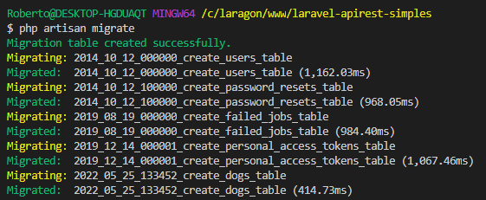

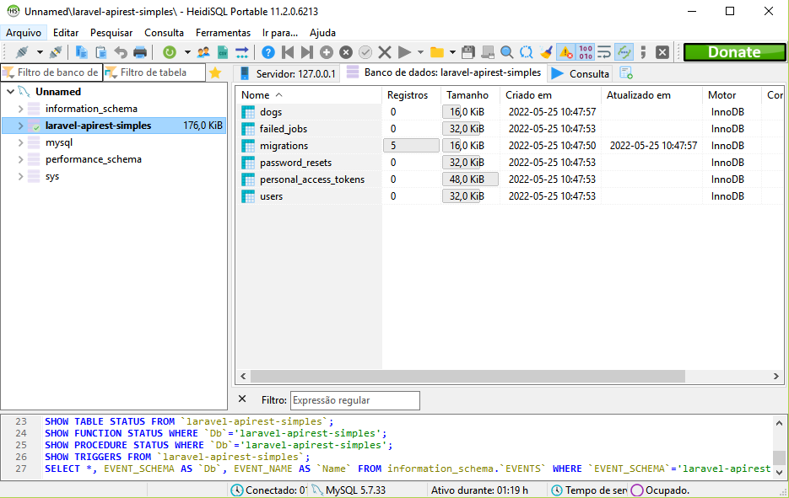

Criando as rotas

routes\api.php

<?php

use Illuminate\Http\Request;
use Illuminate\Support\Facades\Route;

Route::middleware('auth:sanctum')->get('/user', function (Request $request) {
return $request->user();
});

Route::apiResource('dogs', '\App\Http\Controllers\api\DogController');

Criando o controller

php artisan make:controller api/DogController --resource --api

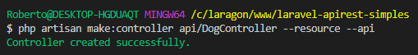

app\Http\Controllers\api\DogController.php

<?php

namespace App\Http\Controllers\api;

use App\Http\Controllers\Controller;
use Illuminate\Http\Request;
use App\Models\Dog;

class DogController extends Controller
{
public function index()
{
return Dog::all();
}

public function store(Request $request)
{
Dog::create($request->all());
}

public function show($id)
{
return Dog::findOrFail($id);
}

public function update(Request $request, $id)
{
$dog = Dog::findOrFail($id);
$dog->update($request->all());
}

public function destroy($id)
{
$dog = Dog::findOrFail($id);
$dog->delete($id);
}
}

Usando o Postman

Inserir dog

POST
http://laravel-apirest-simples.test/api/dogs

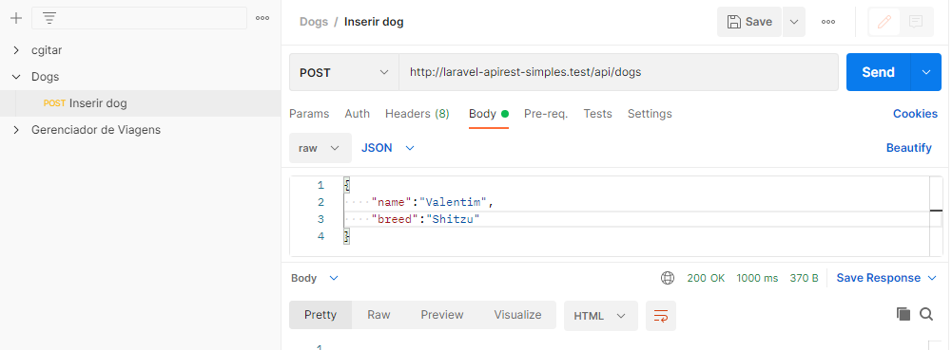

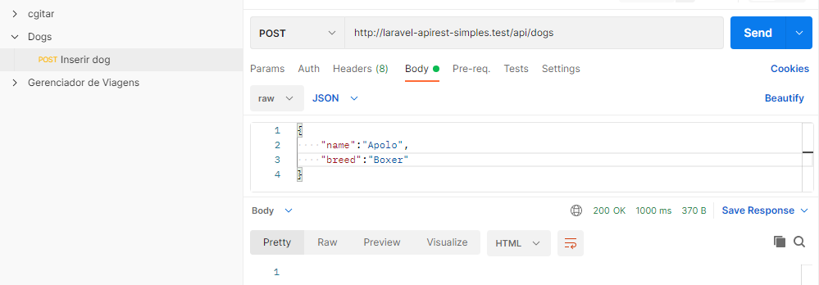

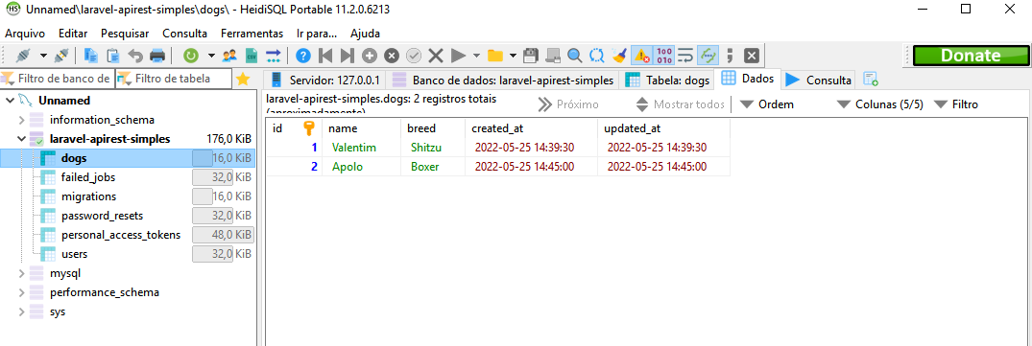

Listar dogs

GET
http://laravel-apirest-simples.test/api/dogs

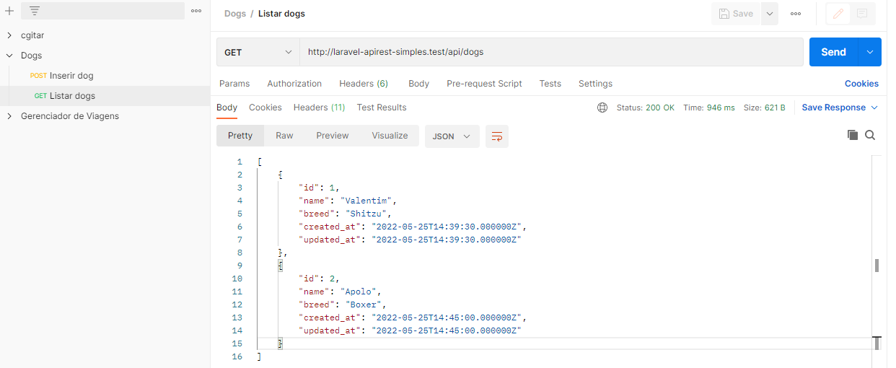

Exibir dados de um dog

GET
http://laravel-apirest-simples.test/api/dogs/2

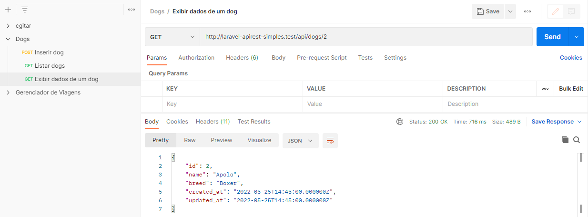

Atualizar dados de um dog

PUT
http://laravel-apirest-simples.test/api/dogs/2

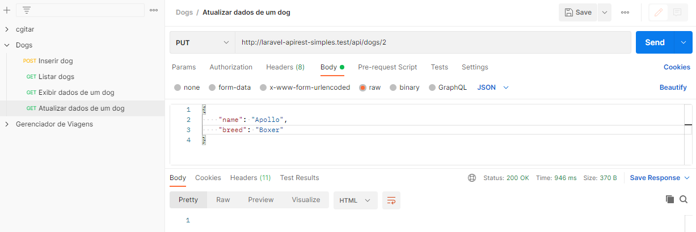

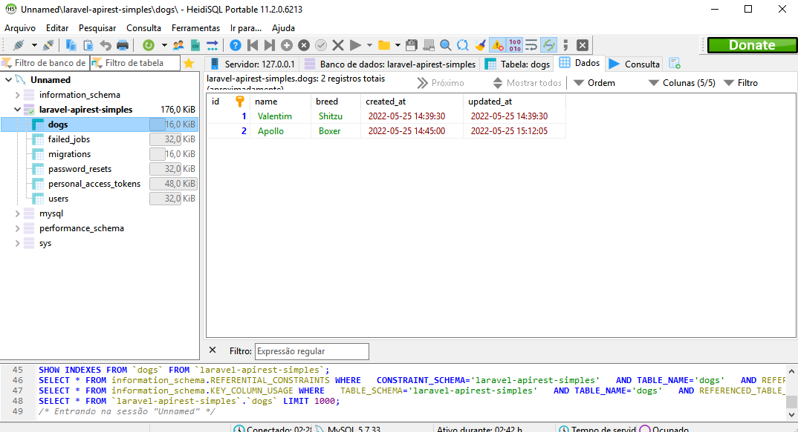

Excluir dog

DELETE
http://laravel-apirest-simples.test/api/dogs/1

